PROJECT REPORT: SCHOOL MANAGEMENT SYSTEM DATABASE
Class: Grade 12 Computer Science
Project Title: Relational Database Design and Implementation for a School Management System
Name: Preyash pokharel
Roll no: 30
Date: 2026/8/16
1. Introduction
This project focuses on the design and implementation of a relational database for a School Management System using MySQL.
The database is designed to store and manage information about students, teachers, courses, enrollments, and attendance. It allows the school to organize student information, maintain course and teacher details, and track student enrollment and attendance.
The project demonstrates important database concepts such as tables, primary keys, foreign keys, constraints, relationships, data insertion, SQL queries, joins, subqueries, aggregate functions, and data modification.
The main objective of this project is to create a structured and efficient database that can store school-related information and retrieve useful information using SQL.
2. Entity-Relationship (ER) Diagram
The database contains the following main entities:
1. Students
Stores information about students in the school.
2. Teachers Stores information about teachers who teach different courses.
3. Courses
Stores information about the courses offered by the school.
4. Enrollments
Connects students with the courses they are enrolled in.
5. Attendance
Stores attendance information of students.
Relationships
- A teacher can teach multiple courses.
- A course can have multiple students.
- A student can enroll in multiple courses.
- enrollments connects students and courses.
- A student can have multiple attendance records

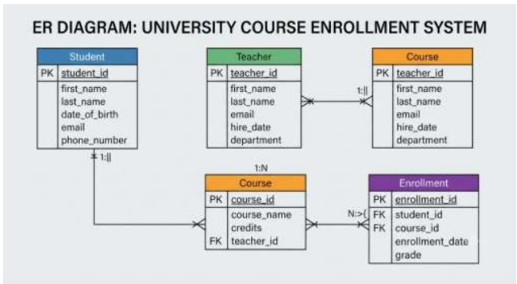
Table-1 : Students
column | Data Type | Constraint | Description
student_id | INT | PRIMARY KEY | Unique ID for each student
first_name | VARCHAR | NOT NULL | Student's first name
last_name | VARCHAR | NOT NULL | Student's last name
gender | VARCHAR | NOT NULL | Student's gender
date_of_birth | DATE | NOT NULL | Student's date of birth
email | VARCHAR | UNIQUE | Student's email
phone | VARCHAR | — | Student's contact number

Table-2 : Teachers
Column | Data Type | Constraint | Description
teacher_id | INT | PRIMARY KEY | Unique ID of each teacher
teacher_name | VARCHAR | NOT NULL | Name of teacher
email | VARCHAR | UNIQUE | Teacher's email
phone | VARCHAR | — | Teacher's contact number
Course_id | INT | FOREIGN KEY | Teacher's contact number

Table -3 : course
Column | Data Type | Constraint | Description
course_id | INT | PRIMARY KEY | Unique ID of course
course_name | VARCHAR | NOT NULL | Name of course
teacher_id/course reference | INT | FOREIGN KEY | Teacher associated with course

Table 4: Enrollments
Column | Data Type | Constraint | Description
enrollment_id | INT | PRIMARY KEY | Unique enrollment ID
student_id | INT | FOREIGN KEY | ID of enrolled student
student_id | INT | FOREIGN KEY | ID of selected course
enrollment_date | DATE | — | Data of enrollment

Table 5: Attendance
Column | Data Type | Constraint | Description
attendance_id | INT | PRIMARY KEY | Unique attendance ID
student_id | INT | FOREIGN KEY | ID of student
attendance_date | DATE | — | Date of attendance
status | VARCHAR | —

4. Database Implementation
The database was implemented using MySQL.
The implementation includes:
- Database creation
- Table creation
- Primary keys
- Foreign keys
- Constraints
- Sample data insertion
The database_setup.sql file contains the SQL commands required to create and populate the database.

4.1 Database Creation
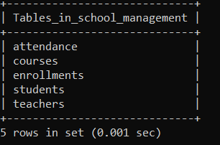

5. Data Insertion
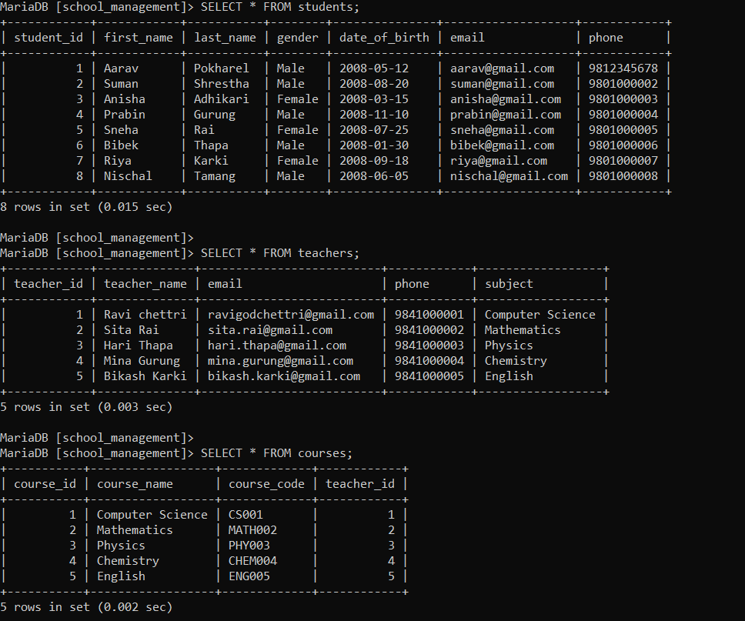
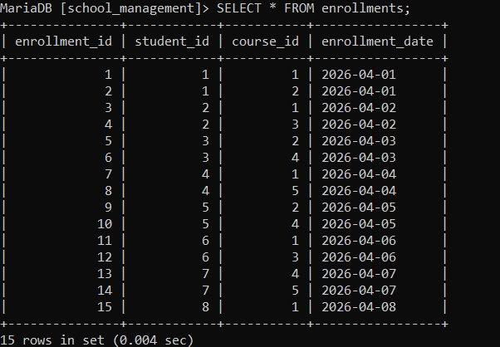

6. Database Querying and Analytics
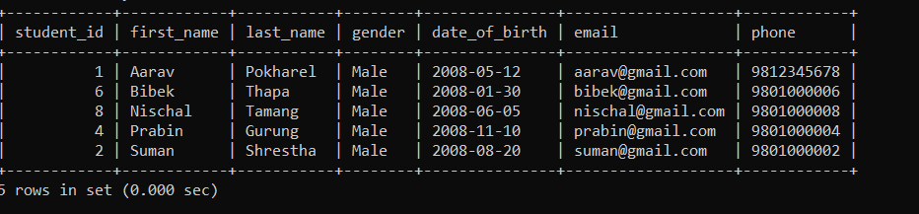

Query 2: Aggregate Function
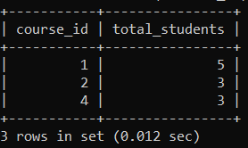
Query 3: Subquery
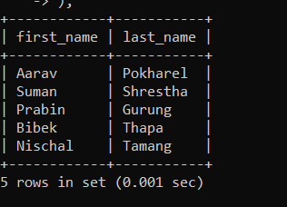
Query 4: INNER JOIN
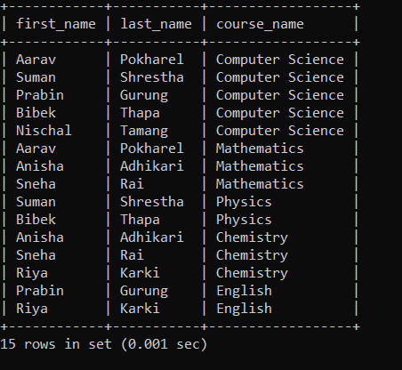

Query 5: LEFT JOIN
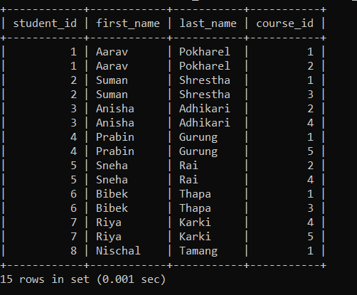

Data Modification
UPDATE
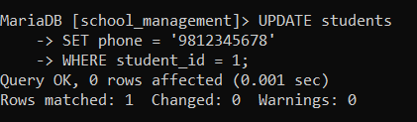

Proof of Successful Execution
Screenshots of the SQL commands and their outputs are included in this report to demonstrate successful execution.
The screenshots show:
- Database and tables
- Basic retrieval
- Aggregate function
- Subquery
- INNER JOIN
- LEFT JOIN
- UPDATE
- DELETE

9. Normalization
The database is designed using the principles of relational database normalization.
First Normal Form (1NF)
Each table contains atomic values, and repeating groups are avoided. Each record can be uniquely identified using a primary key.
Second Normal Form (2NF)
The database avoids partial dependency by ensuring that non-key attributes depend on the appropriate primary key.
Third Normal Form (3NF)
The database separates different types of information into separate tables, reducing unnecessary duplication and ensuring that non-key attributes depend on the key of their respective table.
For example, teacher information is stored in the teachers table instead of repeatedly storing the teacher's details in every course or enrollment record.

10. Conclusion
This project successfully designed and implemented a School Management System relational database using MySQL.
The database contains related tables for students, teachers, courses, enrollments, and attendance. Primary keys and foreign keys were used to establish relationships and maintain data integrity.
Various SQL operations were successfully performed, including basic retrieval, aggregate functions, subqueries, INNER JOIN, LEFT JOIN, UPDATE, and DELETE.
Through this project, practical knowledge of relational database design, normalization, SQL, relationships, data integrity, and database querying was demonstrated.

